14 August 2015

ID: | Name: | Section: 01 & 02
Independent University, Bangladesh
School of Engineering and Computer Science
CSC203- Data Structure
Final Exam, Summer-2015
Time: 1 hour 15 minutes Total marks: 60
Answer any three from the following four questions. [3 X 20 marks = 60 marks]

1. | (a) | Traverse the given tree using Inorder, Preorder and Postorder traversals.  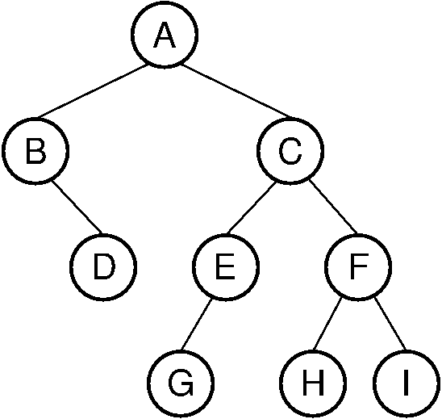 |  | 9
 | (b) | Write down an algorithm / function to clear (delete) all nodes of a binary tree. |  | 8
 | (c) | Definition  Tree?  Full binary tree/ complete binary tree? |  | 3
2. | a)  b) | In the given binary tree, using array store the all nodes indicating their location.  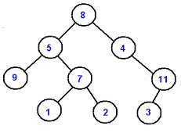  What the different possible ways a node can be detected from a BST?  In a BST, deleting a node that has both children can be performed in two different ways. Explain them. 4+4  Write a algorithm / code insert a node to a binary search tree. 8 |  | 4
  8 | ? | ? | ? | ? | ? | ? | ? | ? | ? | ? | ? | ? | ? | ?
3. | (a) | Assume you are given a Max Heap. Write an algorithm / function / code to display all parents whose value is equal to the summation of its children.  Example:  When your heap is as follows:  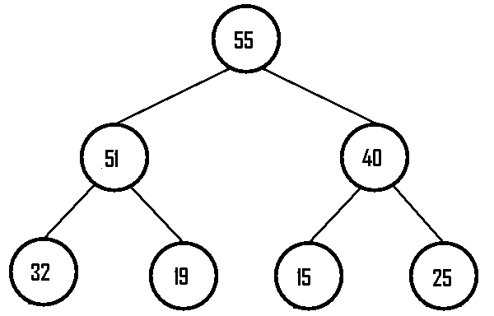  Your program should display 51, 40 [in any order]. |  | 7
 | (b) | Write down the algorithm to delete the highest key value from a Min Heap. |  | 8
 | (c) | State the basic idea to transform a heap into a sorted array. Explain. |  | 5
4. | (a) | What are the advantages of Adjacency List (Linked list based Representation) over Adjacency Matrix (Array based Representation)? |  | 4
 | (b) | Traverse the following graph and display the nodes in the order of their traversal in both DFS and BFS approach. [for nodes at the same level follow alphabetical order]  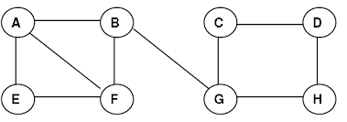 |  | 4+4
 | (c) | Write the algorithm to visit a directed graph and display the nodes in DFS order. |  | 8

